**APACHE HIVE 4.0.1 TUTORIAL**

# 1. Setup

## 1.1 Hadoop clusters

Hệ thống hadoop cluster đã được cài từ trước và đảm bảo chạy tốt

Máy Master

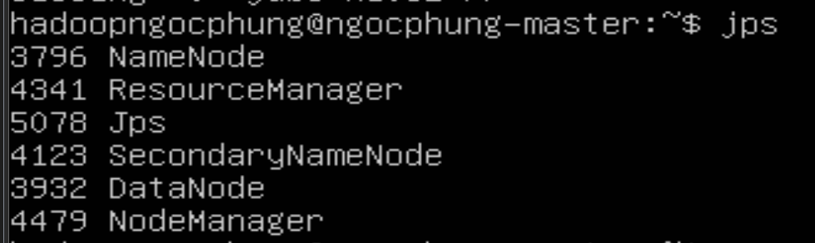

Máy Slave

## 1.2 Chuẩn bị dữ liệu

### 1.2.1 HiveSample.txt

|  |
| --- |
| 1201 Gopal 45000 Technical manager  1202 Manisha 45000 Proof reader  1203 Masthanvali 40000 Technical writer  1204 Kiran 40000 Hr Admin  1205 Kranthi 30000 Op Admin |

### 1.2.2 Partition_1.txt

|  |
| --- |
| 1, gopal, TP, 2012  2, kiran, HR, 2012  3, kaleel, SC, 2013  4, Prasanth, SC, 2013 |

### 1.2.3 Partition_2.txt

|  |
| --- |
| 1, gopal, TP, 2012  2, kiran, HR, 2012 |

### 1.2.4 Partition_3.txt

|  |
| --- |
| 3, kaleel, SC, 2013  4, Prasanth, SC, 2013 |

### 1.2.5 Join_1.txt

|  |
| --- |
| 1,Ramesh,32,Ahmedabad,2000.00  2,Khilan,25,Delhi,1500.00  3,Kaushik,23,Kota,2000.00  4,Chaitali,25,Mumbai,6500.00  5,Hardik,27,Bhopal,8500.00  6,Komal,22,MP,4500.00  7,Muffy,24,Indore,10000.00 |

### 1.2.6 Join_2.txt

|  |
| --- |
| 102,2009-10-08 00:00:00,3,3000  100,2009-10-08 00:00:00,3,1500  101,2009-11-20 00:00:00,2,1560  103,2008-05-20 00:00:00,4,2060 |

## 1.3 Share file vào máy ảo

Vào quyền root

|  |
| --- |
| mkdir /mnt/hgfs |
| /usr/bin/vmhgfs-fuse .host:/ /mnt/hgfs/ -o subtype=vmhgfs-fuse,allow_other |

# 2. Khởi động hive

|  |
| --- |
| hive |

|  |
| --- |
| !connect jdbc:hive2:// |

Sau đó nhập tên username và password

# 3. Apache Hive Tutorials

## 3.1 Create Database

|  |
| --- |
| CREATE SCHEMA ngocphungdb; |

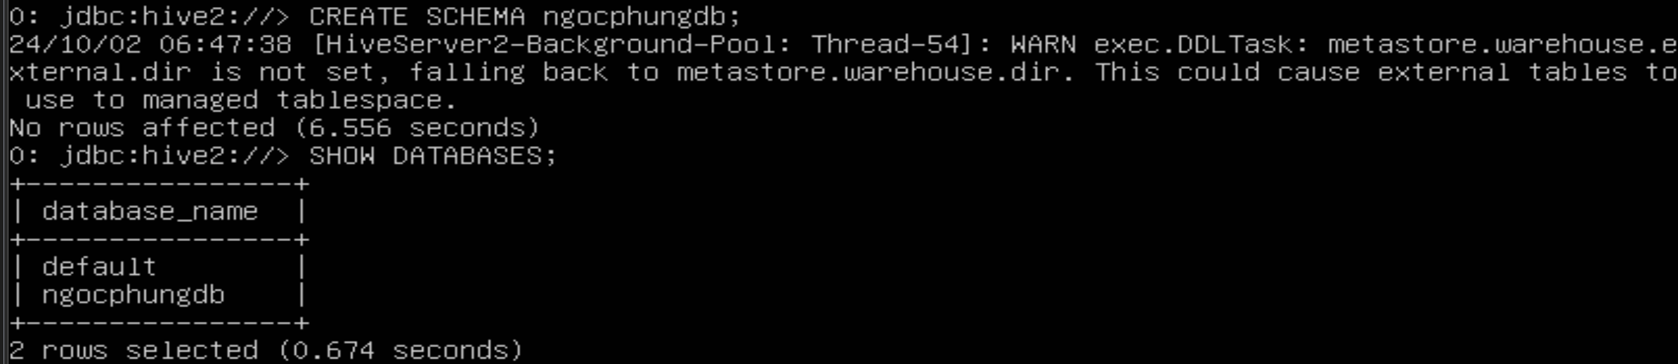

## 3.2 Drop Database

|  |
| --- |
| DROP DATABASE IF EXISTS ngocphungdb; |
| DROP DATABASE IF EXISTS ngocphungdb CASCADE; |

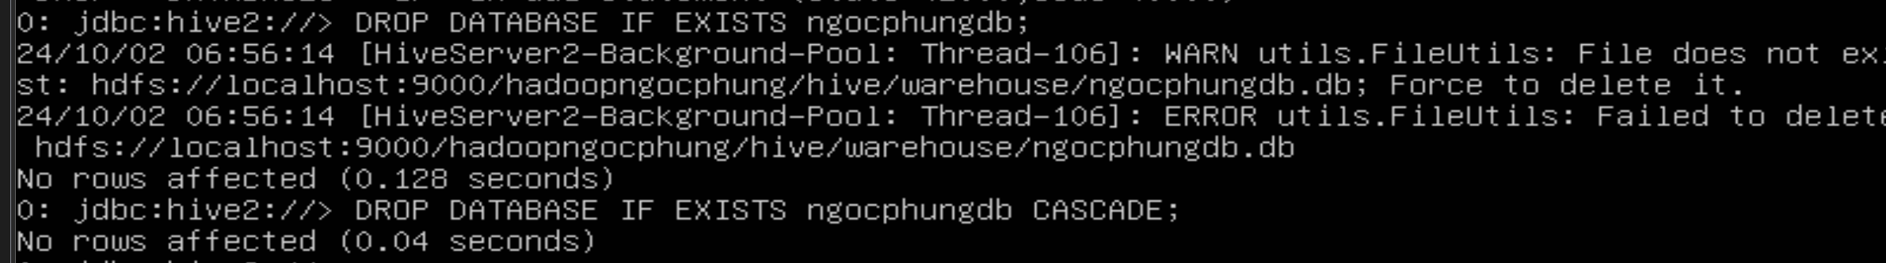

## 3.3 Create Table

|  |
| --- |
| SHOW DATABASES; |
| USE ngocphungdb; |

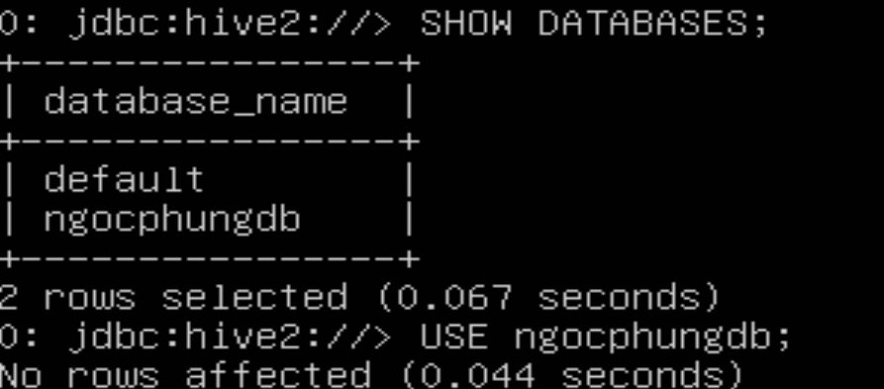

|  |
| --- |
| CREATE TABLE IF NOT EXISTS ngocphung_employee ( eid int, name String, salary Float, destination String) COMMENT 'Employee details' ROW FORMAT DELIMITED FIELDS TERMINATED BY '\t' LINES TERMINATED BY '\n' STORED AS TEXTFILE; |



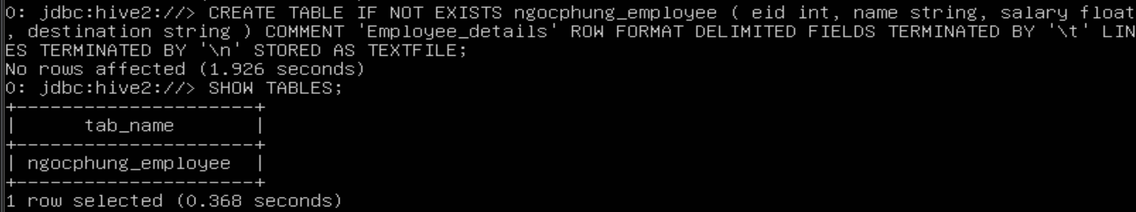

Load data

|  |
| --- |
| LOAD DATA LOCAL INPATH '/home/hadoopngocphung/Apache_Hive/Hive_Tutorial/HiveSample.txt' OVERWRITE INTO TABLE ngocphung_employee; |

## 3.4 Alter Table

|  |
| --- |
| ALTER TABLE ngocphung_employee RENAME TO ngocphung_emp; |

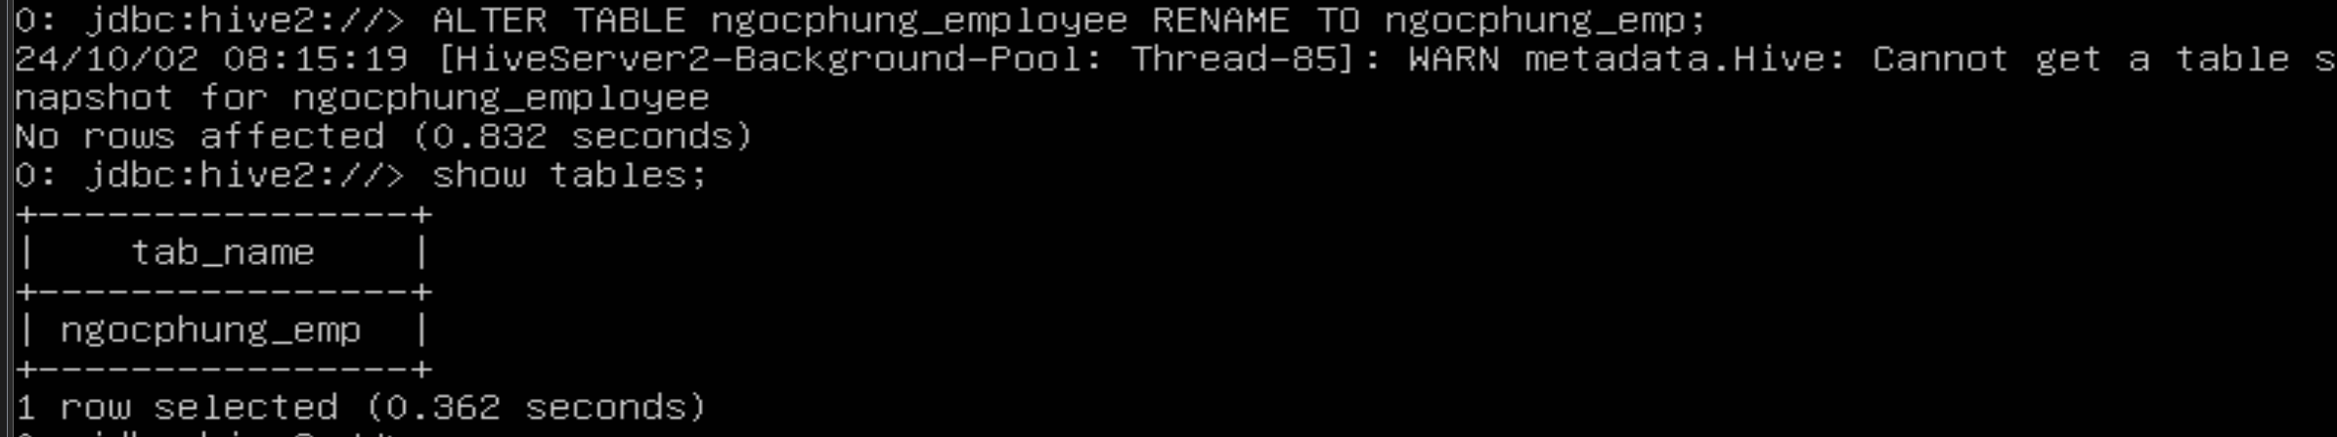

|  |
| --- |
| ALTER TABLE ngocphung_emp CHANGE name ename String; |
| ALTER TABLE ngocphung_emp CHANGE salary salary Double; |

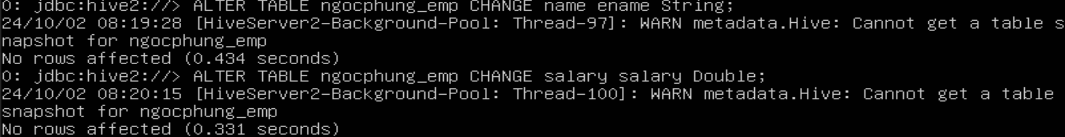

|  |
| --- |
| ALTER TABLE ngocphung_emp ADD COLUMNS (dept STRING COMMENT 'Department name'); |



|  |
| --- |
| ALTER TABLE ngocphung_emp REPLACE COLUMNS ( eid INT empid Int, ename STRING name String); |



Hive không hỗ trợ thay đổi kiểu dữ liệu trực tiếp qua lệnh REPLACE COLUMNS nếu muốn có thể thực hiện các bước như thêm cột mới, sao chép dữ liệu, và đổi tên cột nếu cần.

## 3.5 Drop Table

|  |
| --- |
| DROP TABLE IF EXISTS ngocphung_emp; |



## 3.6 Partitioning

Tạo file

Tạo bảng

|  |
| --- |
| CREATE TABLE employee ( id INT, name STRING, dept STRING, yoj DOUBLE ) PARTITIONED BY (year INT); |

Thêm partition

|  |
| --- |
| ALTER TABLE employee ADD PARTITION (year='2012') location 'hive/tab1/employeedata/part2012'; |

Chỉnh sửa partition

|  |
| --- |
| ALTER TABLE employee PARTITION (year=2012) RENAME TO PARTITION (year=2013); |

Xóa partition

|  |
| --- |
| ALTER TABLE employee DROP PARTITION (year=2013); |

## 3.7 Built-in Operators

Tại lại và load dữ liệu trong bảng ngocphung_employee

|  |
| --- |
| CREATE TABLE IF NOT EXISTS ngocphung_employee ( eid INT, name STRING, salary FLOAT, destination STRING, dept STRING) COMMENT 'Employee details' ROW FORMAT DELIMITED FIELDS TERMINATED BY '\t' LINES TERMINATED BY '\n' STORED AS TEXTFILE; |
| LOAD DATA LOCAL INPATH '/home/hadoopngocphung/Apache_Hive/Hive_Tutorial/HiveSample.txt' OVERWRITE INTO TABLE ngocphung_employee; |
| SELECT * FROM ngocphung_employee; |

|  |
| --- |
| SELECT * FROM ngocphung_employee WHERE eid=1202; |

|  |
| --- |
| SELECT * FROM ngocphung_employee WHERE salary>40000; |

Arithmetic Operators

|  |
| --- |
| SELECT 20+30; |

Logical Operators

|  |
| --- |
| SELECT * FROM ngocphung_employee WHERE salary>40000 AND dept='manager'; |

## 3.8 Built-in Function

|  |
| --- |
| SELECT round(2.6); |

|  |
| --- |
| SELECT floor(2.6); |

|  |
| --- |
| SELECT ceil(2.6); |

## 3.9 View and Indexes

Tạo view chỉ hiện ra các nhân viên có lương trên 30000;

|  |
| --- |
| CREATE VIEW emp_30000 AS SELECT * FROM ngocphung_employee WHERE salary>30000; |
| SELECT * FROM emp_30000; |

|  |
| --- |
| CREATE INDEX inedx_salary ON TABLE ngocphung_employee(salary) AS 'org.apache.hadoop.hive.ql.index.compact.CompactIndexHandler'; |

Trong phiên bản Hive 4.0.1, tính năng indexing (tạo chỉ số) đã không còn được khuyến khích và không được sử dụng rộng rãi do hiệu suất không cao

# 4. HiveQL

## 4.1 Where

|  |
| --- |
| SELECT * FROM ngocphung_employee WHERE salary>30000 |

## 4.2 Order By

|  |
| --- |
| SELECT eid, name, dept FROM ngocphung_employee ORDER BY dept; |

## 4.3 Group By

|  |
| --- |
| SELECT dept,count(*) FROM ngocphung_employee GROUP BY dept; |

## 2.4 Joins

Nội dung file Join_1.txt và Join_2.txt đã chuẩn bị

- Tạo 2 bảng customers và orders

|  |
| --- |
| CREATE TABLE ngocphung_customers (id INT, name STRING, age INT, address STRING, salary DOUBLE) COMMENT 'Customers Details' ROW FORMAT DELIMITED FIELDS TERMINATED BY ',' LINES TERMINATED BY '\n' STORED AS TEXTFILE; |
| CREATE TABLE ngocphung_orders (oid INT, o_date TIMESTAMP, customer_id INT, amount DOUBLE) COMMENT 'Orders Details' ROW FORMAT DELIMITED FIELDS TERMINATED BY ',' LINES TERMINATED BY '\n' STORED AS TEXTFILE; |
| DESCRIBE ngocphung_customers; |
| DESCRIBE ngocphung_orders; |

Load dữ liệu

|  |
| --- |
| LOAD DATA LOCAL INPATH '/home/hadoopngocphung/Apache_Hive/Hive_Tutorial/Join_1.txt' OVERWRITE INTO TABLE ngocphung_customers; |
| LOAD DATA LOCAL INPATH '/home/hadoopngocphung/Apache_Hive/Hive_Tutorial/Join_2.txt' OVERWRITE INTO TABLE ngocphung_orders; |
| DESCRIBE ngocphung_customers; |
| DESCRIBE ngocphung_orders; |

|  |
| --- |
| SELECT c.id, c.name, c.age, o.amount FROM ngocphung_customers c JOIN ngocphung_orders o ON (c.id = o.customer_id); |

đã xảy ra lỗi 

thử tăng giới hạn bộ nhớ cho các tác vụ của Hive bằng cách cấu hình lại tham số trong Hive:

|  |
| --- |
| SET hive.auto.convert.join=false; |



Thử chạy lệnh join trên

LEFT OUTER JOIN:

|  |
| --- |
| SELECT c.id, c.name, c.age, o.amount FROM ngocphung_customers c LEFT OUTER JOIN ngocphung_orders o ON (c.id = o.customer_id); |

RIGHT OUTER JOIN:

|  |
| --- |
| SELECT c.id, c.name, c.age, o.amount FROM ngocphung_customers c RIGHT OUTER JOIN ngocphung_orders o ON (c.id = o.customer_id); |

FULL OUTER JOIN

|  |
| --- |
| SELECT c.id, c.name, c.age, o.amount FROM ngocphung_customers c FULL OUTER JOIN ngocphung_orders o ON (c.id = o.customer_id); |

